

NURSING THEORY

Student's Name

NURSING THEORY

Nursing theory is an organized set of ideas that show a purposeful and structured view of phenomena. Through a structured inquiry in nursing practice or research, nurses develop knowledge pertinent to improving patient care. Nursing is committed to identifying and acknowledging its own unique body of knowledge that is important to nursing practice. To discern this foundation of knowledge, nurses must identify and understand theories and concepts relevant to nursing (Younas& Quennell, 2019).
Nursing Environment
The nursingenvironment can be described as a work setting where nurses get personal satisfaction and accomplish organizational goals. A healthy nursing environment promotes a climate where healthcare professionals are challenged to use clinical knowledge, skills, and expertise. Nurses who work in a healthy nursing environment are encouraged to deliver quality care. The nursing theory equips nurses with the necessary concepts and competencies to provide excellent care in a clinical nursing unit.
The Nursing Needs Theory
The nursing needs theory was proposed by Virginia Henderson and was obtained from her education and practice. However, Henderson's goal was to describe nursing practice's distinctive focus and not develop a nursing theory. The nursing need theory highlights the importance of fostering the patient's independence to expedite recovery after hospitalization (Gligor & Domnariu, 2020). The nursing needs theory emphasizes the basic human needs. Henderson makes three major presuppositions in her model of nursing. These presuppositions are;
- Nurses provide care to patients until they can care for themselves.
- Nurses are willing to serve and commit themselves to the patient day and night.
- Nurses ought to be educated at the college level in sciences as well as arts.
Nursing needs theory addresses four major concepts. These concepts include;
- Individual
Henderson propounds that individuals have basic needs that are significant aspects of health. Individuals may require help to achieve independence, health, or achieve peaceful death (Gligor & Domnariu, 2020).
- The environment
The environment is comprised of settings where an individual learns distinctive patterns of living. The environment also entails external conditions and influences that impact life and development.

- Health
The concept of health is based on a person's ability to function independently. Nurses ought to promote health, prevention, and curing of diseases. The nursing needs theory shows that it is difficult for an individual to achieve good health as it is influenced by various factors, including age, emotional balance, and even cultural background (Cavalcante Fernandes et al., 2016).
- Nursing
Henderson defines the nurse's role as supplementing patients will and knowledge based on his or her needs. Basic nursing care entails providing conditions that foster patient independence in 14 components, including breathing normally, eliminating body wasters, sleep and rest, moving and maintaining desirable postures, dressing appropriately, worshiping according to one's faith, good communication, avoiding dangers in the environment and participating in various forms of recreation.

Strengths of the Nursing NeedsTheory

The concept of nursing promoted by the needs theory is widely accepted in nursing practice. The nursing needs theory and the 14 components are simple, logical, and can be easily implemented on all individuals.
The Relevance of Nursing Needs Theory
Virginia Henderson applied the concepts of basic human needs, interaction communication, bio physiology, and culture, giving the nursing needs theory a holistic coverage of patient needs (Cavalcante Fernandes et al., 2016). The theory's 14 components address patient needs in different aspects, yet they are simple to implement in clinical settings. The nursing needs theory effectively addresses patient needs and explains nurses' roles.

QSEN Competencies
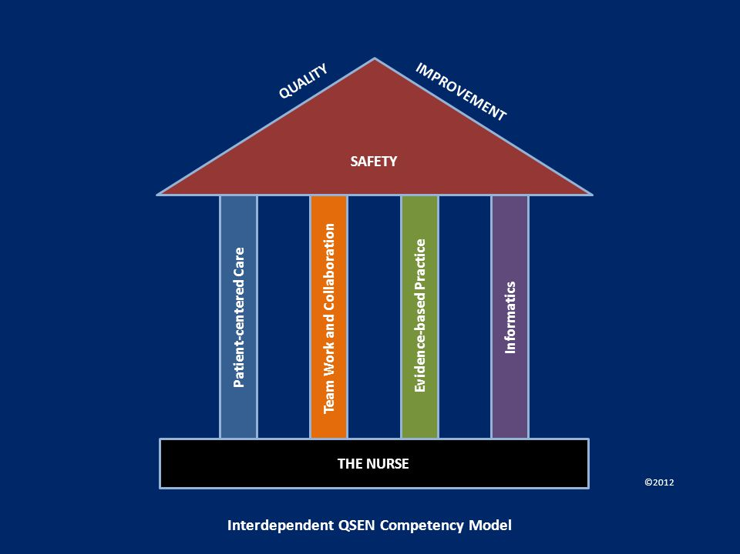
Quality and Safety Education for Nurses guide nurses in nursing care delivery to ensure safe and high-quality care. QSEN seeks to align nursing education and best practices. QSEN identifies knowledge, competencies, and attitudes required to provide safe and high-quality care (Altmiller, 2019).QSEN is based on the following area competencies; patient-centered care, teamwork and collaboration, evidence-based practice, quality improvement, safety, and informatics. Nursing needs theory can be applied in clinical settings. The application of the theory in QSEN competencies entails;
- Patient-centered care
Patient-centered care competency acknowledges the importance of providing care based on patient needs and values. It also recognizes the need to involve patients in decision making regarding their care (Altmiller,2019). The nursing needs process theory entails promoting patient independence to expedite the recovery process.
- Teamwork and collaboration
Teamwork and collaboration competency encompass healthcare professionals collaboratively working together in decision making and providing competent and effective care. Teamwork and collaboration foster open communication in healthcare.

- Evidence-based Practice
This competency is associated with the use of scientifically proven practices and strategies. It combines clinical expertise, best practices, and patient preference.
- Quality Improvement
This involves improving the quality of care provided to patients. This competency relies on data collection, assessment of the care practices, and improving patient health.
- Safety
This competency focuses on preventing patient harm and injury through nurses' performance and the healthcare system's effectiveness. The competency evaluates unsafe practices, human practices, and safety design principles.
- Informatics
This is the use of technology to improve patient safety and quality of care provided.
Henderson's nursing needs theory is an effective theory in nursing practice and a suitable method of describing the nursing essence. The nursing needs theory application is simple, logical, and easy to apply in clinical settings and contexts. This theory is used to improve patient care, and it is based on evidence-based practices. The nursing needs theory can address health disparities as it's based on enhancing patient independence.

References
Altmiller, G. (2019). Care bundles, QSEN, and student learning. Nurse educator, 44(1), 7-8.
Cavalcante Fernandes, B. K., Cavalcante Guedes, M. V., da Silva, L. D. F., Lira Borges, C., & de Freitas, M. C. (2016). NURSING PROCESS BASED ON VIRGINIA HENDERSON APPLIED FOR A WORKING ELDERLY. Journal of Nursing UFPE/Revista de Enfermagem UFPE, 10(9).
Gligor, L., & Domnariu, C. D. (2020). Patient Care Approach Using Nursing Theories-Comparative Analysis of Orem's Self-Care Deficit Theory and Henderson's Model. Acta Medica Transilvanica, 25(2), 11-14.
Younas, A., & Quennell, S. (2019). Usefulness of nursing theory‐guided practice: an integrative review. Scandinavian journal of caring sciences, 33(3), 540-555.

